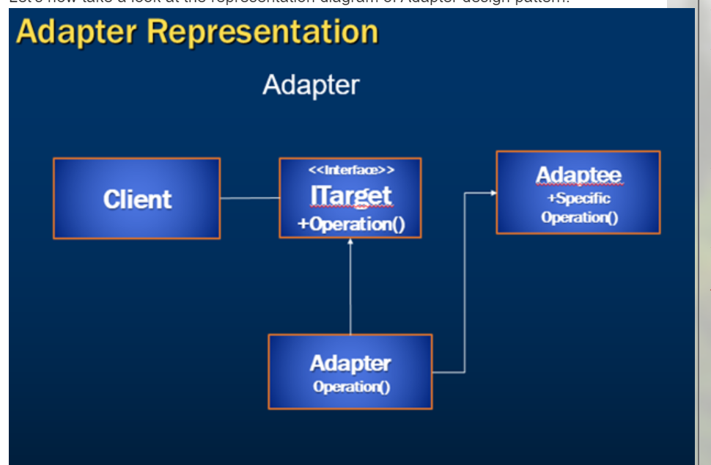

**Definition**

Adapter is a structural design pattern that allows objects with incompatible interfaces to collaborate.



**Use Case: 1**



**Use Case: 2**

Data Transfer Object (DTO) to Business Object.